IT2654 Systems Administration & Security

Tutorial 7

Discuss within your groups and prepare the answers to be presented in class.

- What is a firewall? Describe the 3 types of firewalls ? Which type does Windows firewall fall under?

A device that filters data packets either coming into or going out of a device. Packet filtering (static), stateful packet inspection, proxy server. Windows firewall falls under SPI.

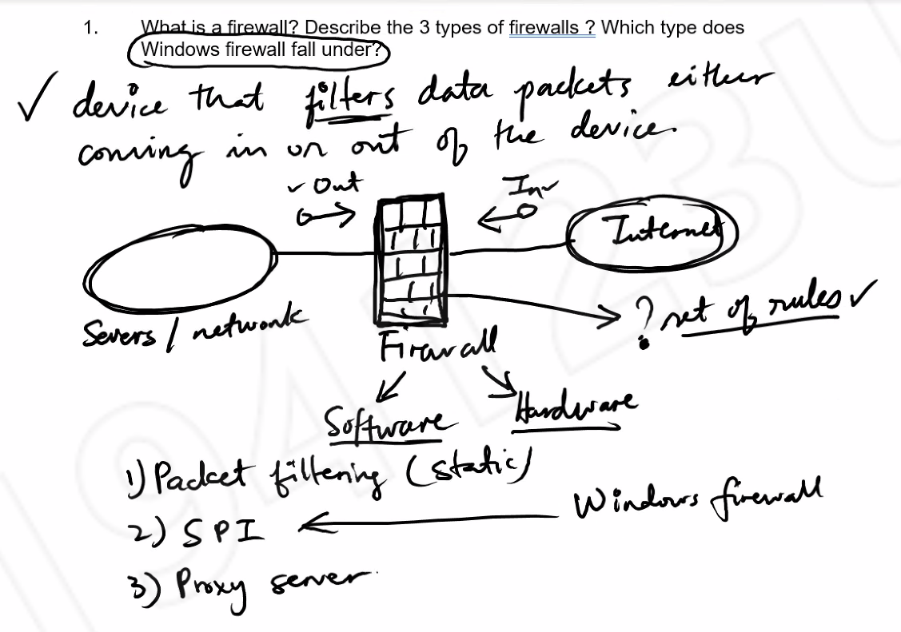

- What is a port under TCP and UDP ? How are ports categorize? Give some examples of well-known ports. What port does the following use?

http://www.nyp.edu.sg
http://www.asus.com:8080

Port is an endpoint to a logical connection for data communication.

Well known ports: 0-1023(80-HTTP), registered ports: 1024-49,151 (3389-Microsoft RDP), dynamic or private ports: 49,152-65,535

1st link: 80 (HTTP, default)
2nd link: 8080

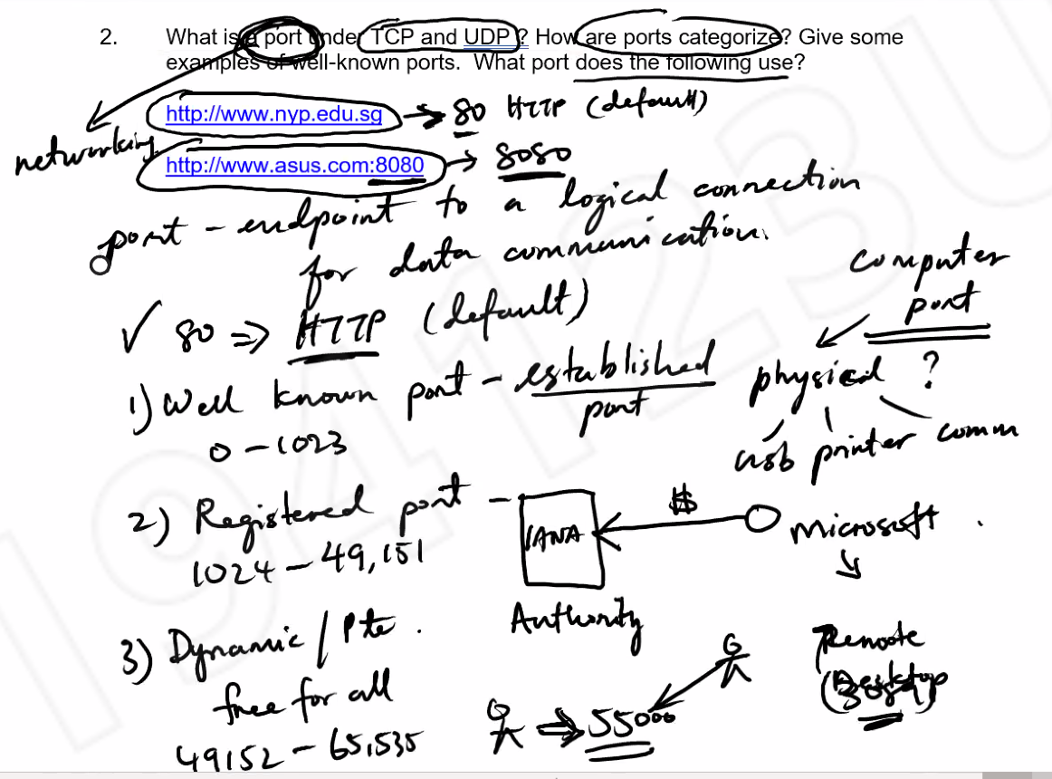

- What is a Windows firewall profile? Describe the 3 types of profiles found in Windows firewall.

Profiles are simply a grouping of firewall rules dependent on where a server is connected.

- Domain Profile
• used when a computer connects to the corporate network.
• device can detect the domain controller.
• Should be the least restrictive because security is usually very well controlled.
- Private Profile
• computers that connect to a private network, such as home or office. In private networks, users are not directly exposed to the Internet.
• Less restrictive than domain profile.
- Public Profile :
• used when computer is connected directly to a public network like a restaurant, library or airport.
• Should be the most restrictive because the network is least secured.

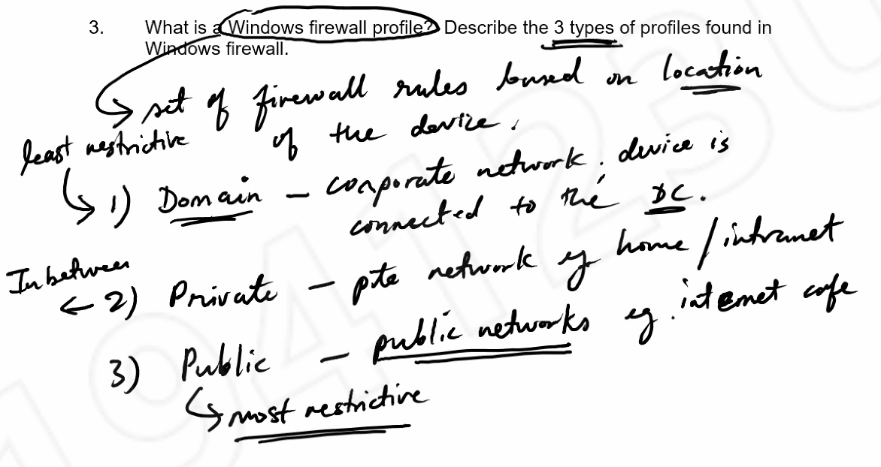

- What is patch management and why is it important for server security? Define zero-day threat or malware. Which type of patch is suitable for zero-day malware?

Process of managing and deploying patches and updates (upgrade app function and update bugs/vulnerability) across the network. Update is super important.

Microsoft defines in 3 ways: hotfix (ad-hoc), patch/rollout (monthly), service pack (April or October).

A zero-day vulnerability is a software security flaw that is known to the software vendor but doesn’t have a patch in place to fix the flaw. It has the potential to be exploited by cybercriminals. Hotfix would work best.

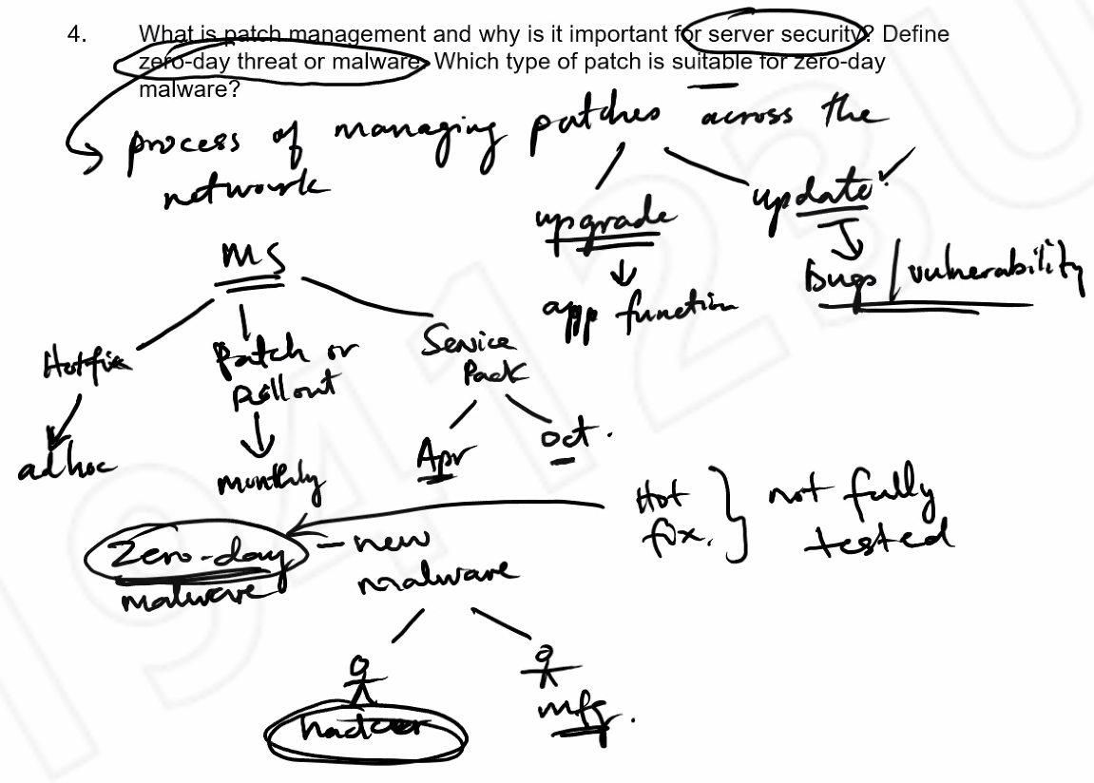

- What are the main components of WSUS and their functions?

Microsoft update distribute updates for Microsoft products
WSUS Server The server that is installed on the Windows Server 2016, which can be used to manage and distribute security updates through administrative console. It can obtain updates from Microsoft Update or from
another WSUS server.
WSUS Console The WSUS Administration Console is automatically
installed on the WSUS server, and it can also be installed on any computer that runs on a supported operating system. You can use the WSUS
Administration Console to manage any WSUS server in any domain with which it has a trust relationship.
Client component The client computer software component that is built
into Windows operating systems. Automatic Updates enables the server and client computers to receive updates from Microsoft Update or from a WSUS
server.

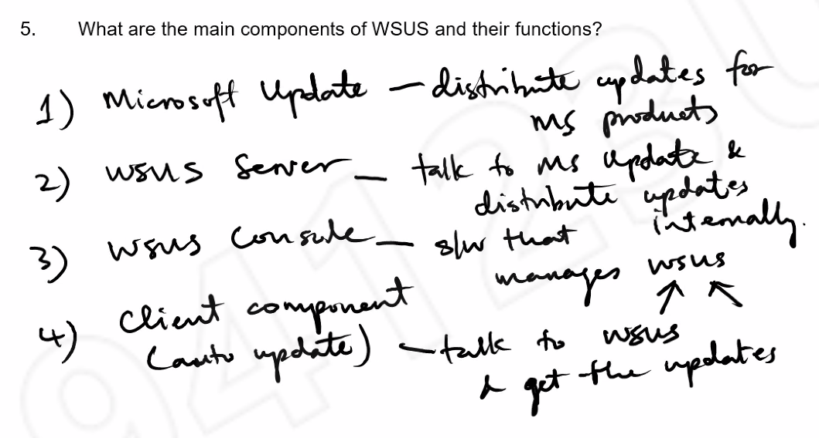

- List the 3 WSUS models and their main characteristic. Which WSUS model would you use in the following? Justify your answer.
- Home PC (none)
- Large enterprise with many servers. (multiple server)
- Singapore Arm Forces. (disconnected server)

Single server Simple network
Multiple server Large network with many servers
Disconnected server Secured network

